**Final Project Report**

Name: Mst Yasmin Ara

SID: S00372402

Course: Backend Web Development

**2.1.1. Student Part:**

* After running the following URL the Student Registration GUI will pop.

<http://localhost/peoject-backend-final/>

* Click on “Register” link

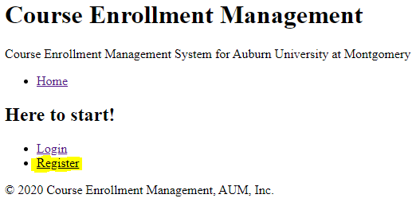

1. **Register**
   * After clicking on “Register” link the Registration GUI will pop up

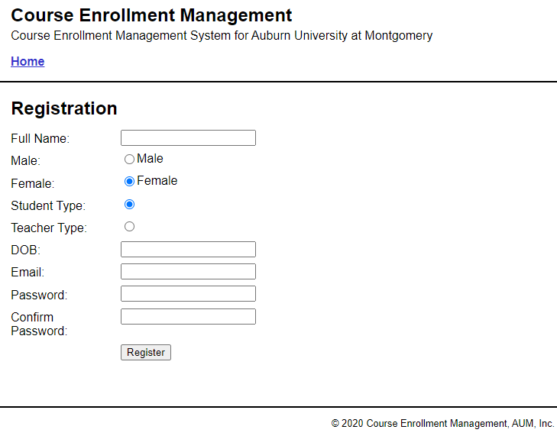

1. **Login**

After submitting the “Registration Form”, “Login Form” will pop up

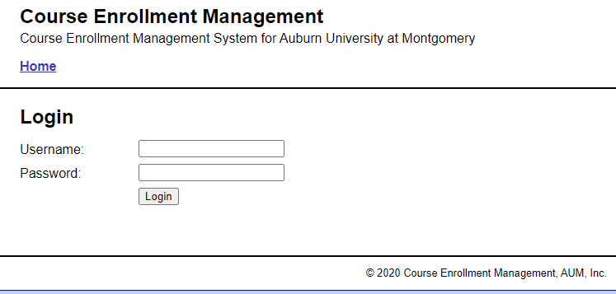

1. **Course Info:**
   * After successfully Logged in the following page will open

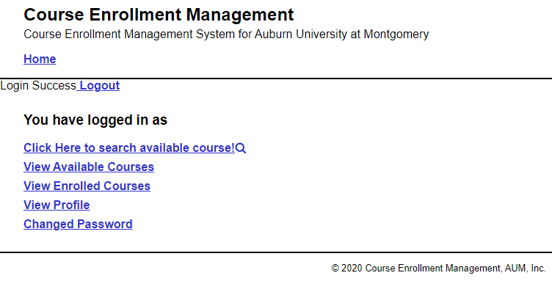

* + Clicking on “View Available Courses” the following table will generate
  + Clicking on ”Enroll” button, the course will be enrolled for the students

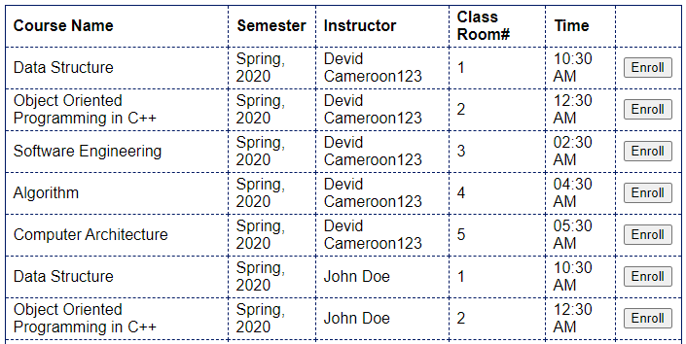

* + Clicking on “View Enrolled Courses” the following table will generate
  + Clicking “Withdraw” button the course will be withdrawal from the students registered course list

1. **Personal Info**

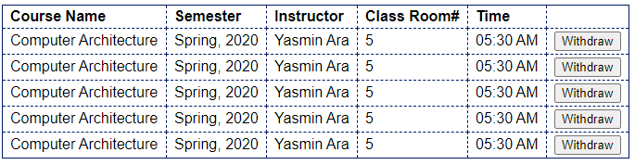

* + Clicking on “View Profile”, a form with profile data will be loaded
  + It will give an option to edit and update the profile for the students

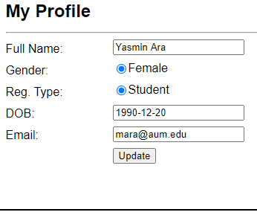

* + Clicking on “Change Password” will give an option to change the current password with a new password

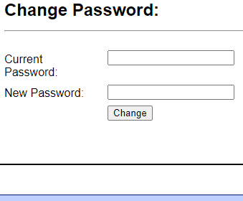

**2.1.2 Instructor**

1. **Register**
   * After clicking on “Register” link the Registration GUI will pop up
   * Select “Teacher Type” for Instractur’s Registration
   * Submit Register Form to register Profile

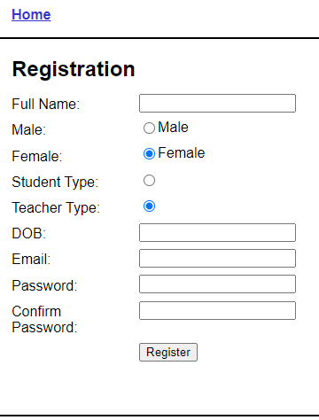

1. **Login**
   * After submitting the “Registration Form”, “Login Form” will pop up



1. **Personal Info**
   * After successfully Logged in the following page will open

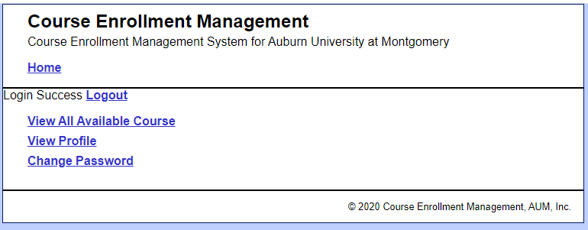

* + Click on “View All Available Course” link and it will show the course list that the instructor going to teach

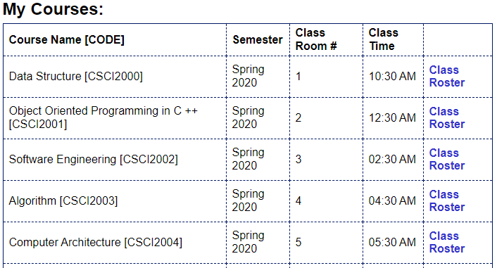

* + “Class Roster” button will show the list of students those haave registered with that course.



1. **Profile**
   * By Clicking on “View Profile” button the profile form with instructor’s profile information will be loaded in the profile form

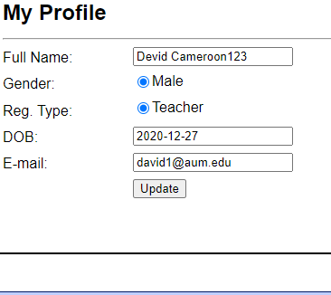

* + Clicking on “Change Password” button there will pop up a GUI that will give an option to change the current password with a new Password.

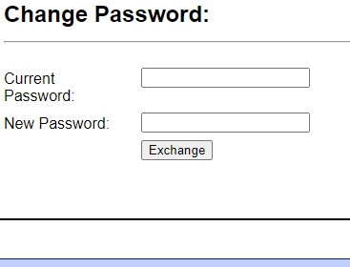

**2.2 Database Design**

-- *************************************************************

-- This script only creates the Course Enrolment Management database

-- *************************************************************

-- create the database

DROP DATABASE IF EXISTS course_enrollment_management;

CREATE DATABASE course_enrollment_management;

-- select the database

USE course_enrollment_management;

-- drop user if it already exists

DROP USER IF EXISTS yasmin@localhost;

-- create user

CREATE USER yasmin@localhost

IDENTIFIED BY 'pagolmon';

-- grant privileges to that user

GRANT SELECT, INSERT, DELETE, UPDATE

ON course_enrollment_management.*

TO yasmin@localhost;

CREATE TABLE `register` (

`reg_id` int(11) NOT NULL AUTO_INCREMENT,

`type` varchar(50) NOT NULL,

`name` varchar(50) NOT NULL,

`email` varchar(50) NOT NULL,

`password` varchar(255) NOT NULL,

`confirm_password` varchar(255) NOT NULL,

`dob` date DEFAULT NULL,

`gender` varchar(10) NOT NULL,

PRIMARY KEY (`reg_id`),

UNIQUE KEY `email` (`email`)

) ENGINE=InnoDB AUTO_INCREMENT=16 DEFAULT CHARSET=utf8mb4;

CREATE TABLE `login` (

`login_id` int(11) NOT NULL AUTO_INCREMENT,

`reg_id` int(11) NOT NULL,

`email` varchar(50) NOT NULL,

`password` binary(64) NOT NULL,

`login_date` date DEFAULT NULL,

PRIMARY KEY (`login_id`)

) ENGINE=InnoDB AUTO_INCREMENT=351 DEFAULT CHARSET=utf8mb4;

CREATE TABLE `course_info` (

`course_id` int(11) NOT NULL AUTO_INCREMENT,

`course_name` varchar(50) NOT NULL,

`course_code` varchar(50) NOT NULL,

`course_credit` int(11) NOT NULL,

`class_room_id` int(11) NOT NULL,

`semester_id` int(11) NOT NULL,

PRIMARY KEY (`course_id`)

) ENGINE=InnoDB AUTO_INCREMENT=31 DEFAULT CHARSET=utf8mb4;

CREATE TABLE `instructor_course_info` (

`instructor_course_info_id` int(11) NOT NULL AUTO_INCREMENT,

`instructor_id` int(11) NOT NULL,

`course_id` int(11) NOT NULL,

PRIMARY KEY (`instructor_course_info_id`)

) ENGINE=InnoDB AUTO_INCREMENT=31 DEFAULT CHARSET=utf8mb4;

CREATE TABLE `student_course_info` (

`student_course_info_id` int(11) NOT NULL AUTO_INCREMENT,

`student_id` int(11) NOT NULL,

`course_id` int(11) NOT NULL,

`instructor_id` int(11) NOT NULL,

`if_enrolled` bit(1) NOT NULL DEFAULT b'0',

PRIMARY KEY (`student_course_info_id`)

) ENGINE=InnoDB AUTO_INCREMENT=7 DEFAULT CHARSET=utf8mb4;

CREATE TABLE `semester_info` (

`semester_id` int(11) NOT NULL AUTO_INCREMENT,

`semester_name` varchar(45) NOT NULL,

`Year` varchar(45) NOT NULL,

PRIMARY KEY (`semester_id`)

) ENGINE=InnoDB AUTO_INCREMENT=7 DEFAULT CHARSET=utf8mb4;

CREATE TABLE `class_room_info` (

`class_room_id` int(11) NOT NULL AUTO_INCREMENT,

`time` varchar(45) NOT NULL,

PRIMARY KEY (`class_room_id`)

) ENGINE=InnoDB AUTO_INCREMENT=11 DEFAULT CHARSET=utf8mb4;

CREATE TABLE `letter_grade` (

`letter_grade_id` int(11) NOT NULL AUTO_INCREMENT,

`reg_id` int(11) NOT NULL,

`course_id` int(11) NOT NULL,

`grade` varchar(10) DEFAULT NULL,

PRIMARY KEY (`letter_grade_id`)

) ENGINE=InnoDB AUTO_INCREMENT=12 DEFAULT CHARSET=utf8mb4;

CREATE TABLE `profile` (

`profile_id` int(11) NOT NULL AUTO_INCREMENT,

`reg_id` int(11) NOT NULL,

`name` varchar(50) NOT NULL,

`date_of_birth` date NOT NULL,

`gender` varchar(50) NOT NULL,

`email` varchar(50) NOT NULL,

PRIMARY KEY (`profile_id`)

) ENGINE=InnoDB DEFAULT CHARSET=utf8mb4;

INSERT INTO register VALUES(DEFAULT, 'teacher' , 'Devid Cameroon', 'david@aum.edu', 'dc@36117','dc@36117','2020-12-29', 'male' );

INSERT INTO register VALUES(DEFAULT, 'teacher' , 'John Doe', 'jdoe@aum.edu', 'jd@36117','dc@36117','2020-12-29', 'male' );

INSERT INTO register VALUES(DEFAULT, 'teacher' , 'Susan Fletcher', 'sfletcher@aum.edu', 'sf@36117','sf@36117','2020-12-29', 'female' );

INSERT INTO register VALUES(DEFAULT, 'student' , 'John Sina', 'jsina@aum.edu', 'jc@36117','jc@36117','2020-12-29', 'male' );

INSERT INTO register VALUES(DEFAULT, 'student' , 'Ron Michael', 'ron@aum.edu', 'ron@36117','ron@36117','2020-12-29', 'male' );

INSERT INTO register VALUES(DEFAULT, 'student' , 'Debbie Roy', 'roy@aum.edu', 'roy@36117','roy@36117','2020-12-29', 'female' );

INSERT INTO course_info VALUES(default, 'Data Structure', 'CSCI2000', 3, 1,1);

INSERT INTO course_info VALUES(default, 'Object Oriented Programming in C++', 'CSCI2001', 3, 2,1);

INSERT INTO course_info VALUES(default, 'Software Engineering', 'CSCI2002', 3, 3,1);

INSERT INTO course_info VALUES(default, 'Algorithm', 'CSCI2003', 3, 4,1);

INSERT INTO course_info VALUES(default, 'Computer Architecture', 'CSCI2004', 3, 5,1);

INSERT INTO course_info VALUES(default, 'Data Structure', 'CSCI2000', 3, 1,2);

INSERT INTO course_info VALUES(default, 'Object Oriented Programming in C++', 'CSCI2001', 3, 2,2);

INSERT INTO course_info VALUES(default, 'Software Engineering', 'CSCI2002', 3, 3,2);

INSERT INTO course_info VALUES(default, 'Algorithm', 'CSCI2003', 3, 4,2);

INSERT INTO course_info VALUES(default, 'Computer Architecture', 'CSCI2004', 3, 5,2);

INSERT INTO course_info VALUES(default, 'Data Structure', 'CSCI2000', 3, 1,3);

INSERT INTO course_info VALUES(default, 'Object Oriented Programming in C++', 'CSCI2001', 3, 2,3);

INSERT INTO course_info VALUES(default, 'Software Engineering', 'CSCI2002', 3, 3,3);

INSERT INTO course_info VALUES(default, 'Algorithm', 'CSCI2003', 3, 4,3);

INSERT INTO course_info VALUES(default, 'Computer Architecture', 'CSCI2004', 3, 5,3);

INSERT INTO class_room_info VALUES(default, '10:30 AM');

INSERT INTO class_room_info VALUES(default, '12:30 AM');

INSERT INTO class_room_info VALUES(default, '02:30 AM');

INSERT INTO class_room_info VALUES(default, '04:30 AM');

INSERT INTO class_room_info VALUES(default, '05:30 AM');

INSERT INTO semester_info VALUES(default, 'Spring', '2020');

INSERT INTO semester_info VALUES(default, 'Summer', '2020');

INSERT INTO semester_info VALUES(default, 'Fall', '2020');

INSERT INTO instructor_course_info VALUES(DEFAULT, 2, 1);

INSERT INTO instructor_course_info VALUES(DEFAULT, 2, 2);

INSERT INTO instructor_course_info VALUES(DEFAULT, 2, 3);

INSERT INTO instructor_course_info VALUES(DEFAULT, 2, 4);

INSERT INTO instructor_course_info VALUES(DEFAULT, 2, 5);

INSERT INTO instructor_course_info VALUES(DEFAULT, 3, 1);

INSERT INTO instructor_course_info VALUES(DEFAULT, 3, 2);

INSERT INTO instructor_course_info VALUES(DEFAULT, 3, 3);

INSERT INTO instructor_course_info VALUES(DEFAULT, 3, 4);

INSERT INTO instructor_course_info VALUES(DEFAULT, 3, 5);

INSERT INTO instructor_course_info VALUES(DEFAULT, 4, 1);

INSERT INTO instructor_course_info VALUES(DEFAULT, 4, 2);

INSERT INTO instructor_course_info VALUES(DEFAULT, 4, 3);

INSERT INTO instructor_course_info VALUES(DEFAULT, 3, 4);

INSERT INTO instructor_course_info VALUES(DEFAULT, 3, 5);

INSERT INTO student_course_info VALUES

(DEFAULT, 1,1,2, 0),

(DEFAULT, 1,2,2, 0),

(DEFAULT, 1,3,2, 0),

(DEFAULT, 1,4,2, 0),

(DEFAULT, 1,5,2, 0),

(DEFAULT, 5,1,3, 0),

(DEFAULT, 5,2,3, 0),

(DEFAULT, 5,3,3, 0),

(DEFAULT, 5,4,3, 0),

(DEFAULT, 5,5,3, 0),

(DEFAULT, 6,1,4, 0),

(DEFAULT, 6,2,4, 0),

(DEFAULT, 6,3,4, 0),

(DEFAULT, 6,4,4, 0),

(DEFAULT, 6,5,4, 0),

(DEFAULT, 7,1,2, 0),

(DEFAULT, 7,2,2, 0),

(DEFAULT, 7,3,2, 0),

(DEFAULT, 7,4,2, 0),

(DEFAULT, 7,5,2, 0);

**2.3 Website Implementation**

**2.3.1 Required Skills**

1. PHP and MySQL-🡪 All most all pages used PHP and MySQL
2. HTML form processing 🡪 utilized by registration.php, login.php, search_result.php, student_dashboard.php, teacher_dashboard.php, enrolled_student_list.php, index.php

3. Control statements including if-else and loops🡪 index.php

4.String processing, e.g., splitting, concatenating, etc. 🡪DAO.php, index.php

5.Arrays. 🡪 index.php, DAO.php

6.Sessions. 🡪index.php, login.php, student_dashboard.php, teacher_dashboard.php, logout.php

1. Custom functions 🡪 if_password_matched.php
2. Objects 🡪 database.php, registration.php

**2.4 Optional Skills**

1. HTML 5 🡪 All pages
2. CSS 3 🡪 header.php (main.css)
3. Javascript (including jQuery, Vue, Angular, etc.) 🡪login.php, registration.php, student_dashboard.php, teacher_dashboard.php used jquery.min.js

**2.5 Bonus Skills**

1. MVC Pattern 🡪 Followed MVC pattern in all pages
2. Cloud Services 🡪 hosted in S3 by creating instance in EC2 and Configuring Apache and MySQL as well

Please click the link below

http://3.19.242.33/peoject-backend-final/